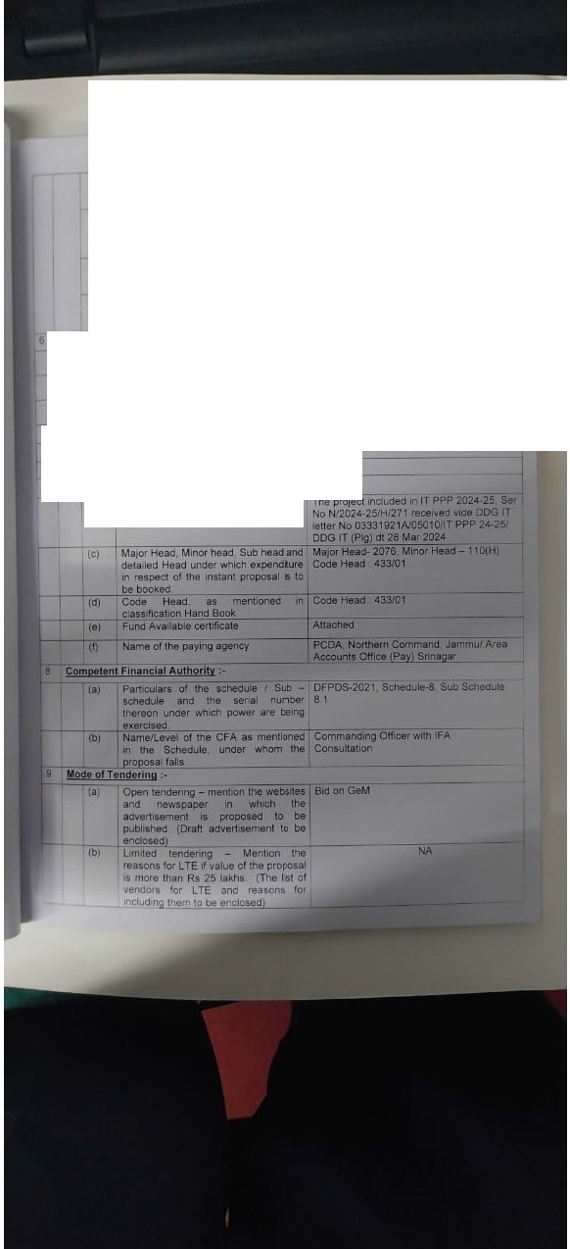
1c
Ma1kitl lnlell'091\C8 - Soorce Pe,lod
etc: to be ment10M<I alo'1Q with , ...,,,
enclo-1ure1
NA
id R111e1 obtained
from otierl
NA
oroan11auon1· Source1 PetlOd quarMy etc 10 be ment10C1ed along w 1t1 rttlev11nl enc!OltHBI
(e) NA
be e'lclo•utos
111 Any other Melhod' adopted !lo oe spac fied and explained alcng with tne ret11son11
Ootallt of ihe! 1 1 1 ourcheH ;.
IOeta1ed rea1on!ng and 1nput1 UHd to
Ptofen1onal officer's Evaluatlon-
NA
The quanbty and detee °"which similar
ltem1were procured nlast Qf1e Yea·
U 11 la 'recurring tem, the total pe-iod
10'which the ttem1 are be1
oc:ur!.d
.(c) The "1ode of tendering in respec: o•
{dl nie !.ource or last purchase
la11pur""'""-------
-+-- crjAny oHl&r relevant nforinaUon
-: /\v•ll•bl•of Fund2 -
tal Is.it 1r11 ludeid In the PPP uf apphcable)? Yes
(b> --rryes, relevant S(!f1;;i1 number of pp:t to --- ----
be auoted
NA
NA
NA
NA
Nil

